PRACTICAL-1

OBJECTIVE - TO CREATE EC2 INSTANCE
Steps to Create an EC2 Instance
1. Login to AWS
o Go to AWS Management Console.
o Sign in with your credentials.
2. Navigate to EC2
o In the search bar, type EC2 and select it.
3. Launch Instance
o Click Instances → Launch Instance.
o Give your instance a name.
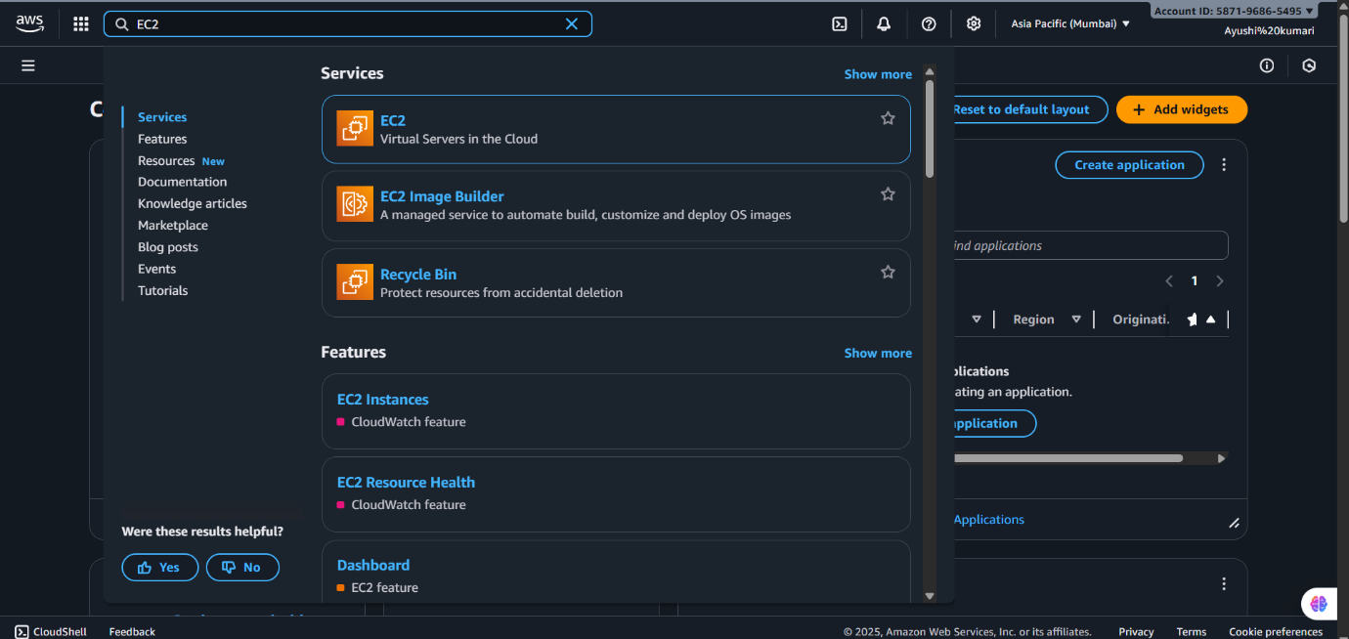

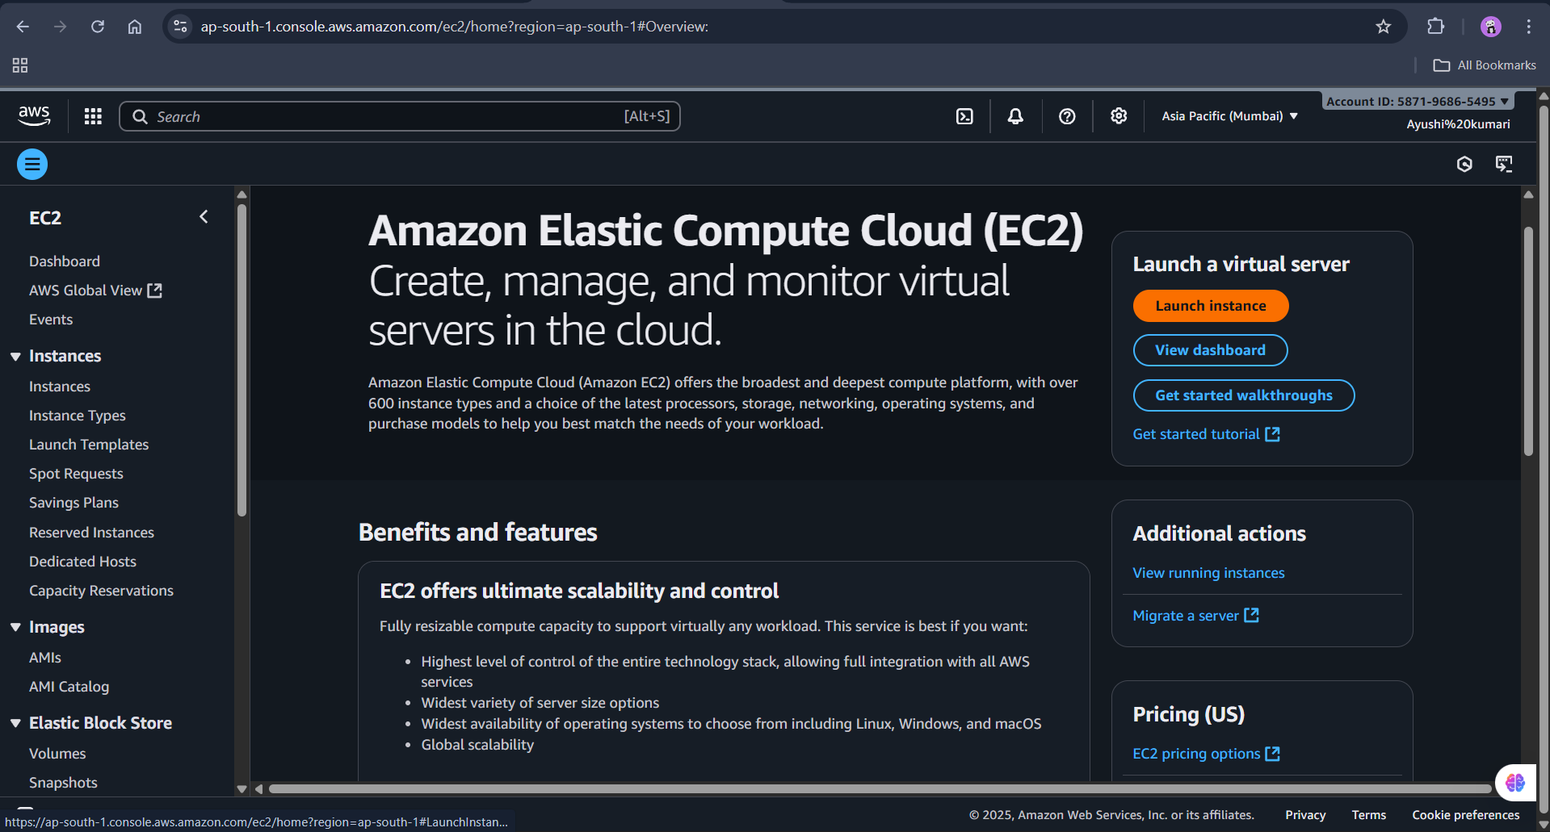

4. Choose Amazon Machine Image (AMI)
o Select an OS image (e.g., Amazon Linux 2, Ubuntu, Windows).
o For beginners, choose Amazon Linux 2 (Free tier eligible).
5. Choose Instance Type
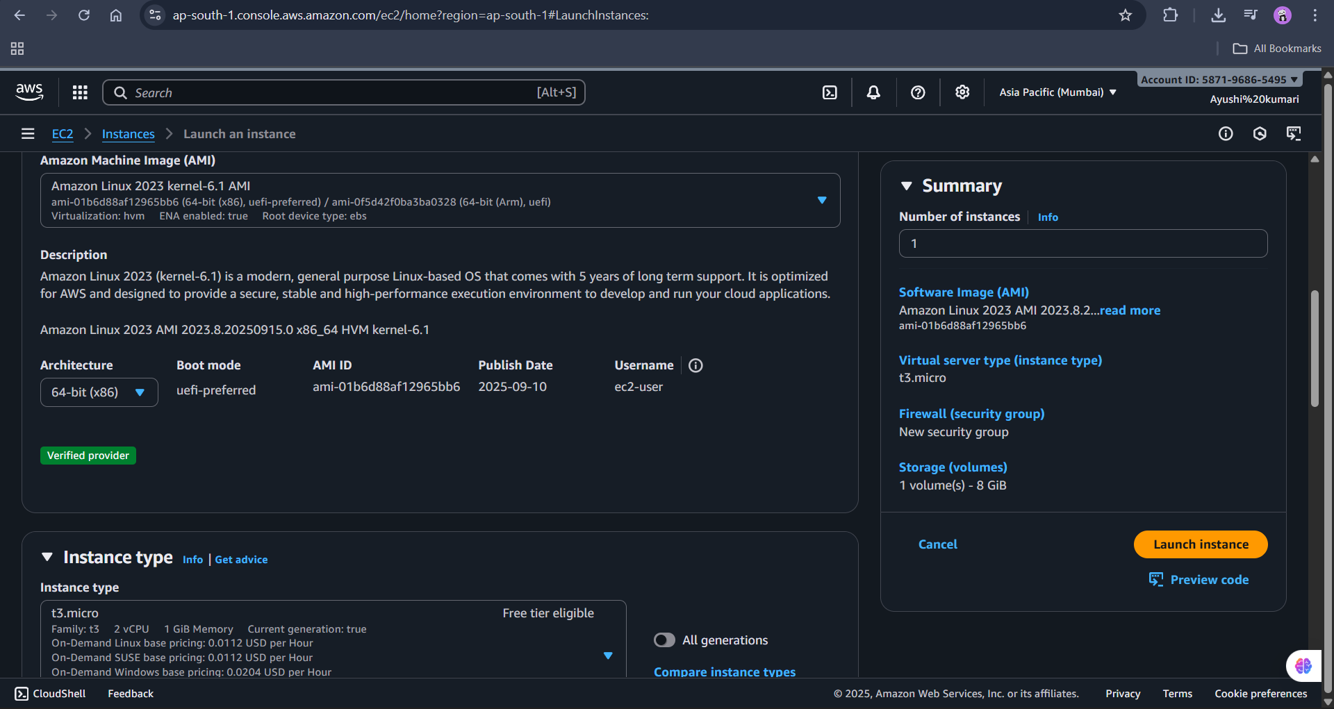
o Select t3.micro (free tier eligible).
6. Configure Key Pair
o Create a new key pair (RSA) and download the .pem file.
o This will be used later to connect to your instance.
7. Configure Network & Security
o Leave default VPC and subnet (unless you want custom networking).
o Under Security group, allow:
SSH (port 22) for Linux
RDP (port 3389) for Windows
HTTP/HTTPS if you’re hosting a website.

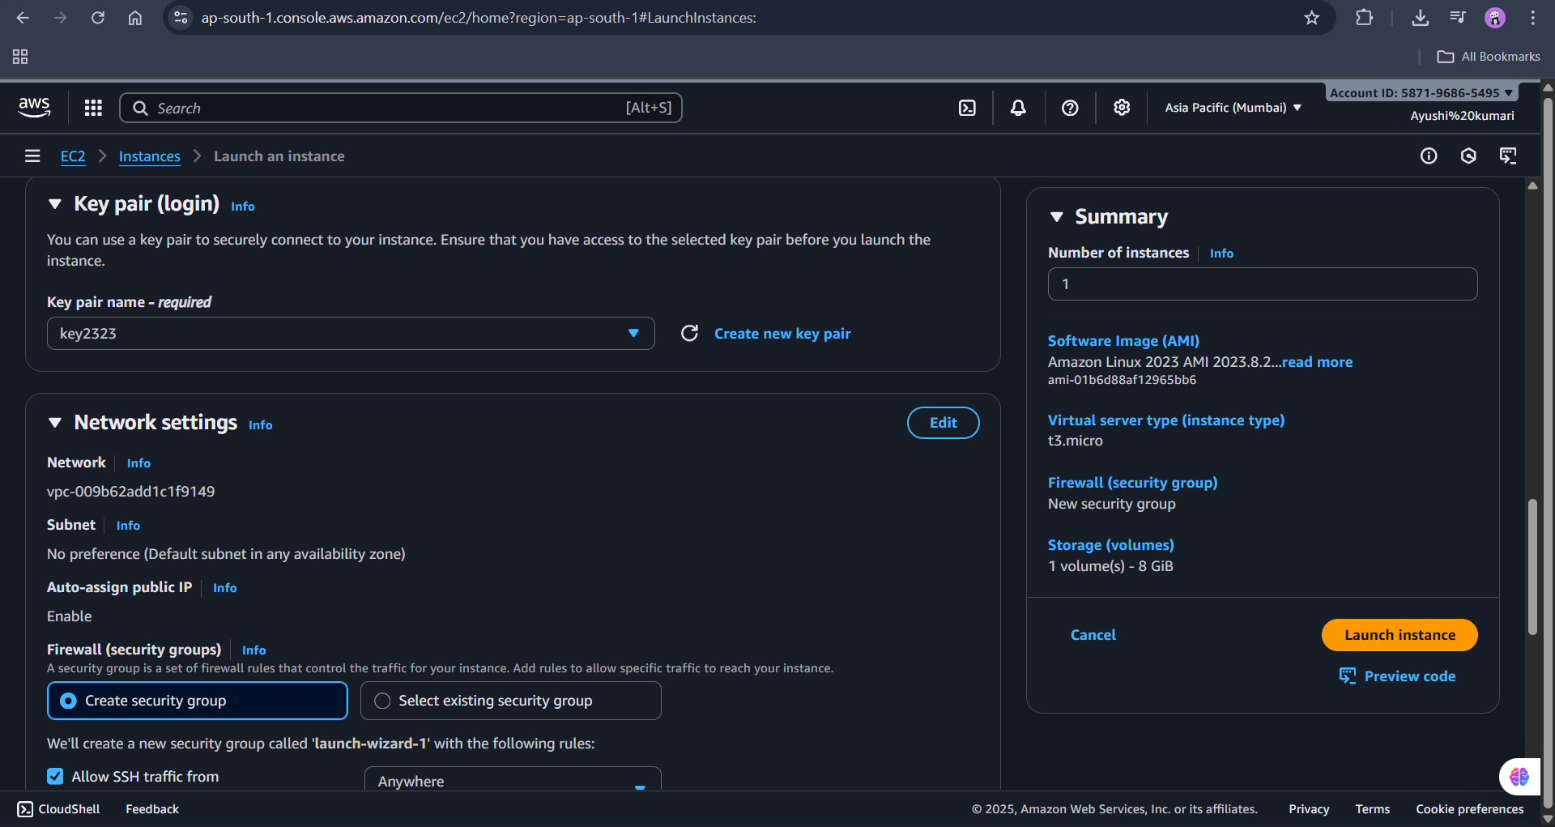

8. Configure Storage
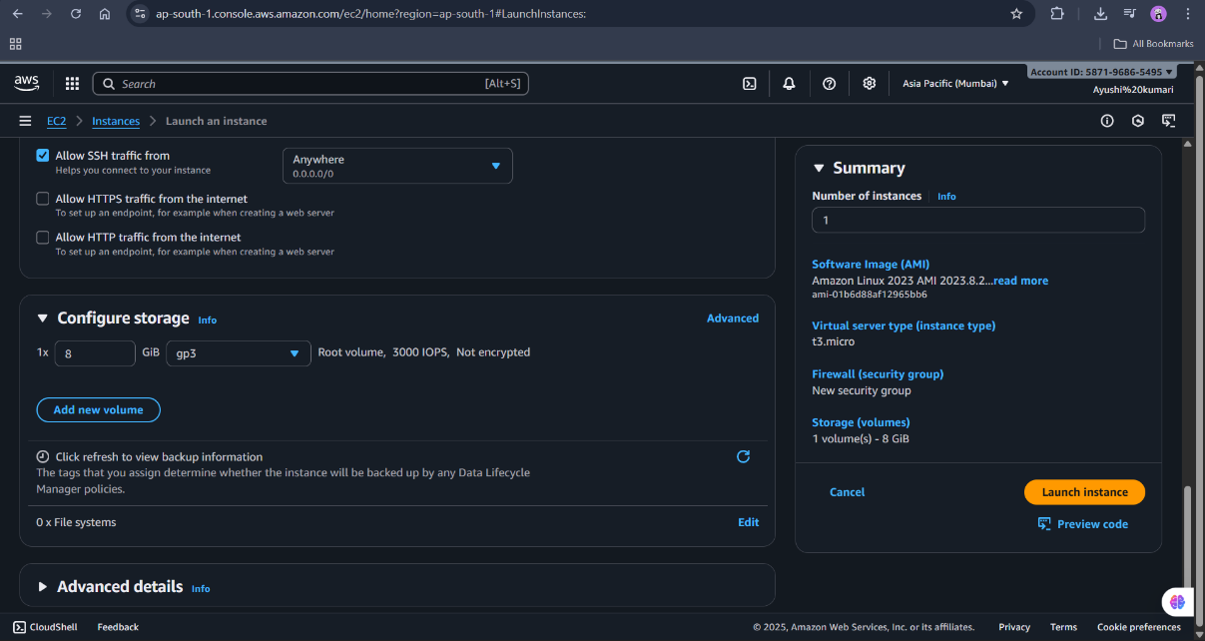
o Default 8 GB is fine (increase if needed).

9. Launch Instance
- Click Launch Instance.
- AWS will start your instance.
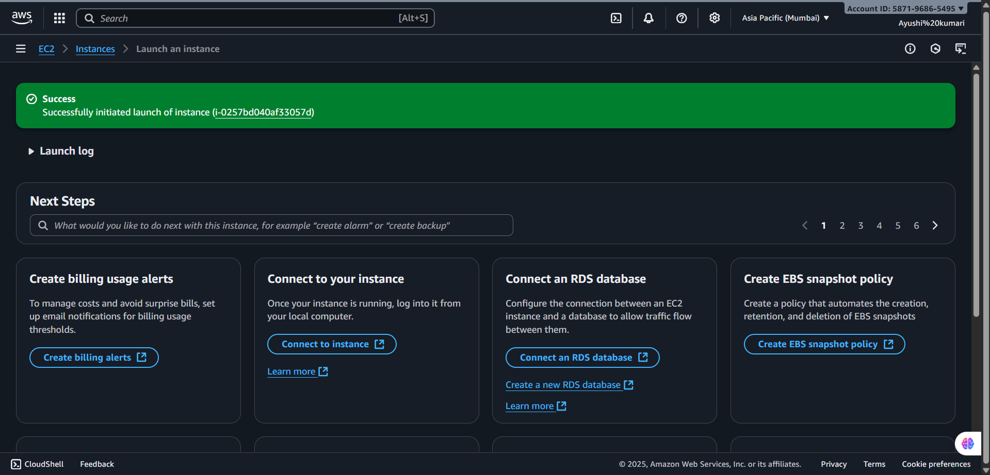

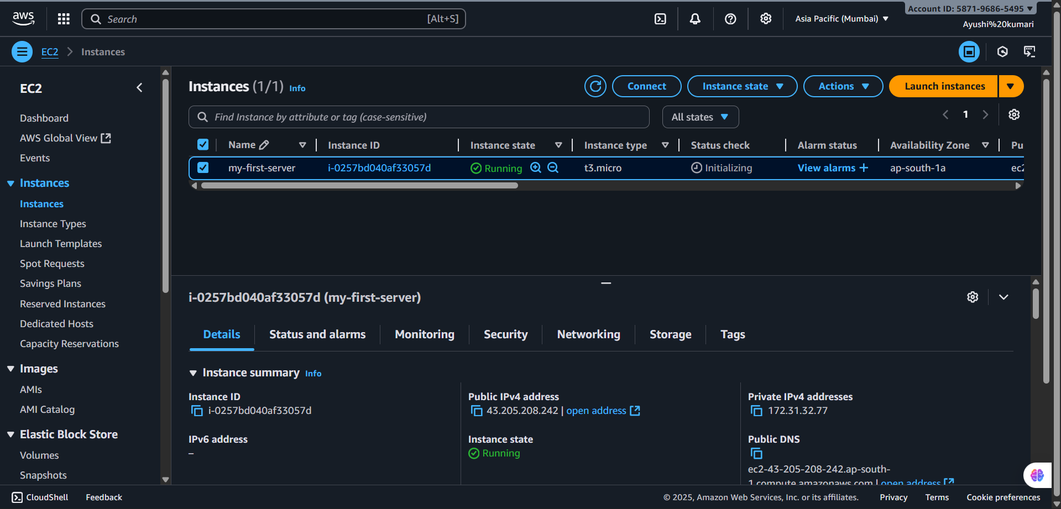
10. Now connect

